Wireframe Of

AI-Powered Data Analysis System

Revision Number: 1.8

Last date of revision: 22/08/2024

**BY :- VIRAJ TUPE**

**Detailed Wireframe Description**

The wireframe for the AI-Powered Data Analysis System offers a visual and functional guide to the user interface (UI). It is designed to facilitate user interactions by clearly defining the layout and functionality for uploading data, initiating analysis, and viewing results. This detailed description covers various aspects of the wireframe, including user interface components, interactions, and navigation flow.

**Wireframe Overview**

The wireframe is structured to provide a seamless user experience, focusing on intuitive design and accessibility. It ensures that users can easily upload data, analyze it, and view the results without encountering unnecessary complexity. The layout is designed to be both user-friendly and functional, supporting a variety of data analysis tasks.

**Wireframe Diagrams**

**1. API Endpoint Layout**

The API endpoints are designed to handle specific user requests and interactions with the backend system. Here is a detailed description of each endpoint:

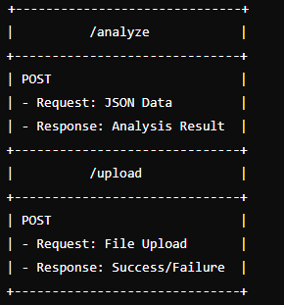

* **/analyze Endpoint**
  + **Method:** POST
  + **Request:** Accepts JSON data containing parameters for data analysis, such as model type and configuration.
  + **Response:** Returns the results of the analysis, including performance metrics and predictions.
* **/upload Endpoint**
  + **Method:** POST
  + **Request:** Accepts file uploads (e.g., CSV files) containing the dataset to be analyzed.
  + **Response:** Provides feedback on the success or failure of the upload, including details about any errors encountered.

**2. User Interface Layout (Web App Example)**

The user interface is divided into several sections, each serving a specific function. The layout is designed to be clean and intuitive, with easy navigation between different sections.

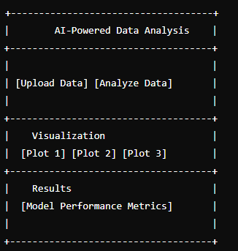

* **Header**
  + **Title:** Displays the name of the application, "AI-Powered Data Analysis."
  + **Navigation:** Provides access to different sections of the application, such as data upload and analysis.
* **Upload Data Section**
  + **Function:** Allows users to upload their datasets.
  + **Components:**
    - **Upload Button:** A button to select and upload files.
    - **File Input:** A field for users to choose the file from their local system.
    - **Progress Indicator:** Displays the upload progress and any errors encountered.
* **Analyze Data Section**
  + **Function:** Initiates the data analysis process.
  + **Components:**
    - **Analyze Button:** A button to start the analysis once the data is uploaded.
    - **Model Selection:** Dropdown or selection field to choose the machine learning model.
    - **Configuration Options:** Fields to set parameters for the selected model.
* **Visualization Section**
  + **Function:** Displays graphical representations of data and analysis results.
  + **Components:**
    - **Plots:** Interactive charts and graphs to visualize data trends and model outputs.
    - **Filters:** Options to filter and customize the displayed plots.
* **Results Section**
  + **Function:** Shows the performance metrics and analysis results.
  + **Components:**
    - **Performance Metrics:** Displays metrics such as Mean Squared Error (MSE), R-squared, and other relevant statistics.
    - **Analysis Summary:** A brief summary of the findings and conclusions from the analysis.

**Detailed Description of Sections**

**1. Upload Data Section**

The Upload Data Section is crucial for users to input their datasets into the system. The design should focus on ease of use and error handling:

* **Upload Button:** Prominently displayed to attract user interaction. Clicking the button opens a file dialog for selecting the dataset.
* **File Input Field:** Supports drag-and-drop functionality for ease of file selection.
* **Progress Indicator:** Provides real-time feedback on the upload status, including progress bars and error messages if the upload fails.

**2. Analyze Data Section**

After uploading the data, users move to the Analyze Data Section to start the analysis:

* **Analyze Button:** Initiates the analysis process. It should be clearly labeled and positioned for easy access.
* **Model Selection Dropdown:** Allows users to choose from available machine learning models. Each model may have associated configuration options.
* **Configuration Options:** Provides fields for setting parameters like learning rate, number of epochs, or other model-specific settings.

**3. Visualization Section**

The Visualization Section is designed to help users understand and interpret their data through graphical representations:

* **Interactive Plots:** Include charts such as line graphs, bar charts, and scatter plots. Users should be able to interact with these plots, such as zooming in or hovering for more details.
* **Filters and Customization:** Options to filter the data shown in plots, such as by date range or specific variables. Customization options allow users to adjust colors, labels, and other visual aspects.

**4. Results Section**

The Results Section provides users with detailed insights into the analysis:

* **Performance Metrics Display:** Clearly shows key metrics like MSE and R-squared, with explanations of what these metrics indicate about the model's performance.
* **Analysis Summary:** Provides a summary of the analysis results, including interpretations and potential next steps.

**User Interaction Flow**

1. **Data Upload:** Users start by uploading their dataset through the Upload Data Section. The system processes the file and prepares it for analysis.
2. **Data Analysis:** Once the data is uploaded, users proceed to the Analyze Data Section to configure and initiate the analysis. The system runs the selected model and prepares the results.
3. **Visualization:** Users can view and interact with visualizations in the Visualization Section to gain insights into the data and model performance.
4. **Results Review:** Finally, users review the results in the Results Section, where they can see performance metrics and a summary of the analysis.

**Enhancements and Future Considerations**

* **User Experience Improvements:** Implement additional features like drag-and-drop file uploads, real-time progress updates, and more intuitive error handling.
* **Accessibility Features:** Ensure the interface is accessible to all users, including those with disabilities, by following best practices for web accessibility.
* **Mobile Responsiveness:** Optimize the UI for mobile devices to ensure users can interact with the system on various platforms.

The wireframe for the AI-Powered Data Analysis System is designed to provide a clear, user-friendly interface for uploading data, performing analysis, and viewing results. Its layout and functionality aim to streamline the data analysis process, making it accessible and efficient for users.

**6. System Architecture Diagram**

The system architecture for the AI-powered data analysis platform includes several key modules that interact to provide a seamless user experience. Below is an overview of the architecture:

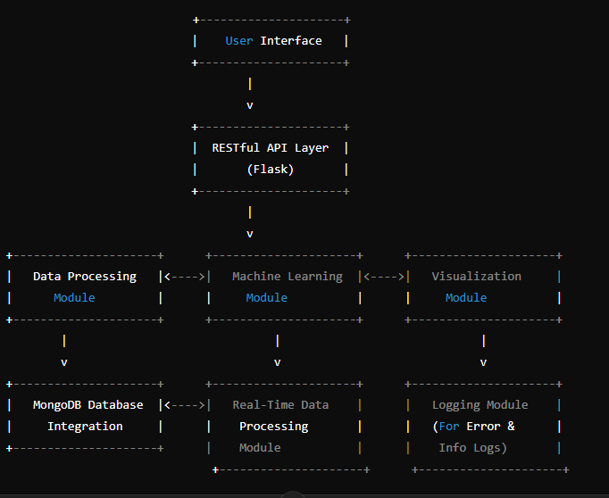

**7. Wireframe Documentation**

**1. API Endpoint Layout:**

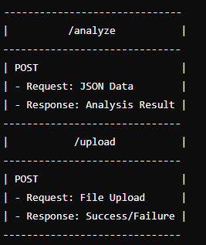

2. User Interface Layout (if developed as a web app):

